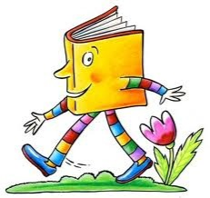Let’s Take a Book Walk

A Book Walk is having a conversation with your student around a book before you read it.

Picture Book Walk
A picture walk is not reading the book. It’s talking about the pictures—getting to know the book together.

What to do:
- Without reading the words in the book, encourage the student to turn the pages one at a time.
- Point to a picture and ask, “What do you think is happening?
- Ask the student, “What might happen next?”

Prediction Book Walk

What to do:
- Look at the cover.
- Point to and say name of author and title.
- Looking at the cover, ask the student what he thinks the book will be about.

Five “W and One H Book Walk
- Use the five "W" and one "H" question words (who, what, when, where, why and how) to stimulate a discussion of the story.
- Examples: “What is happening on this page? Where do you think they are going?”

Critical Vocabulary Book Walk
Introduce or explain words and what they mean.
- Repeat what the student says using different words.
- Add a bit more information to what the student says.

ONE TO ONE Training

