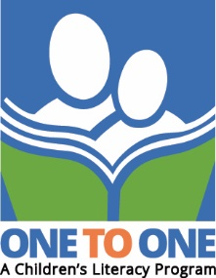

ONE TO ONE – A Children’s Literacy Program

Our school is very fortunate to have the benefit of a volunteer reading program called ONE TO ONE Literacy. ONE TO ONE’s trained volunteer tutors work with students on an individual basis to increase their reading confidence and to practice their reading skills. The one-to-one reading sessions take place within the regular school day at our school.

Students who participate in this program are selected by their teachers. Students are identified as needing to practice reading and boost their literacy skills. Typically, each student spends approximately 30 minutes two times a week with a volunteer tutor, in a relaxed environment where it is okay to take risks, make mistakes, and learn at their own pace. There is no cost to students to participate.

If you would like more information about ONE TO ONE or wish to volunteer with the program, please visit the website: www.one-to-one.ca.

